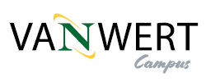
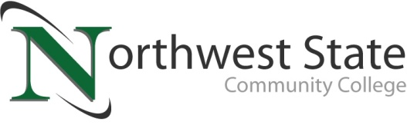

DATE: November 17, 2023
CONTACT: Jim Bellamy 419.267.1267 jbellamy@NorthwestState.edu

NORTHWEST STATE COMMUNITY COLLEGE BEGINS DEMOLITION
AT VAN WERT CAMPUS SITE WITH CEREMONIAL EVENT

van wert, Ohio – Northwest State Community College hosted a ceremonial demolition event for community leaders, elected officials, and other special guests at its Van Wert Campus (the former Kennedy Manufacturing building) on November 16th. As part of the event, Timothy Schneider presented a proclamation from Senator JD Vance to Northwest State for their ongoing work serving Paulding and Van Wert (and surrounding) counties.

“WE ARE NOW HERE TO STAY…”
Following opening remarks by NSCC President Dr. Todd Hernandez, Board of Trustees Chair Scott Mull of Van Wert provided some inspired comments about the importance of having a full-service campus in Van Wert. “In the past, we have dabbled in providing a local presence but we are now here to stay with the purchase and development of this space. We have spent over $1 million acquiring this property and have estimated a cost of an additional $4.8 million we will be spending in renovations to make this space worthy of the educational opportunities you deserve,” Mull stated. Following Mull, local and state officials spoke about their excitement for NSCC providing a full-service campus to the area, and the opportunities it will provide learners, local businesses, and the economy.

STAY UPDATED ON VAN WERT CAMPUS HAPPENINGS
NSCC continues to offer classes in Van Wert at Van Wert Hospital, as well as online, while the Van Wert Campus undergoes demolition and renovation. The College will also endeavor to regularly document building progress via NSCC social media, as well as online at NorthwestState.edu/VanWert.

###

Northwest State Community College is an accredited two-year, state-assisted institution of higher education that has served northwest Ohio since 1969. Northwest State is committed to providing a quality, affordable education with personal attention and small class sizes. The College offers associate degrees with numerous transfer options, short-term certificate programs, and workforce training programs designed to meet the needs of local businesses and industries. For more information, visit NorthwestState.edu or call 419.267.5511.

Media images are available online at
https://northweststate.smugmug.com/20231116-Van-Wert-campus-demolition-MEDIA/

Right click twice to save any image you want to use. Let me know if you have any issues accessing the gallery.

