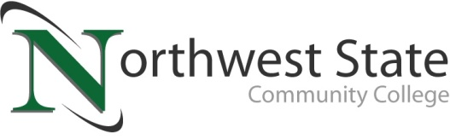

DATE: October 12, 2023
CONTACT: Jim Bellamy 419.267.1267 jbellamy@NorthwestState.edu

NORTHWEST STATE COMMUNITY COLLEGE RAISES $16,000
FOR STUDENT SCHOLARSHIPS AT 3rd ANNUAL VAN WERT CAMPUS GOLF OUTING

Archbold, Ohio – Northwest State Community College recently hosted its 3rd Annual Van Wert Campus Golf Outing on Friday, September 15th at Hickory Sticks Golf Club in Van Wert. 96 participants enjoyed a fun day of golf, games and prizes, all in an effort to raise NSCC scholarship dollars for Paulding and Van Wert learners. In total, approximately $16,000 was raised as a result of the event.

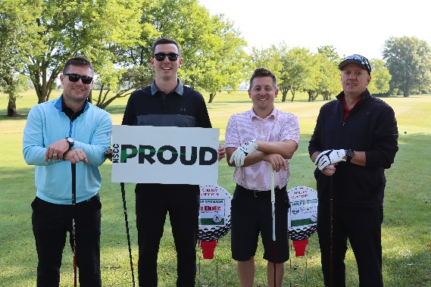
“PAULDING AND VAN WERT LEARNERS WILL BENEFIT…”
Figure 1NSCC hosted their 3nd Annual Van Wert golf outing on September 16 at Hickory Sticks Golf Club in Van Wert. One of the many golfing teams is shown here [Names not available].
Northwest State serves a six-county service area of Williams, Fulton, Defiance, Henry, Paulding and Van Wert counties. Nearly 25% of the six-county population resides in Paulding and Van Wert counties. NSCC is working diligently in hopes that the full-service Van Wert campus is up and running for the fall 2024 semester.

The money raised at the golf outing will go towards scholarships specifically for Paulding and Van Wert learners. NSCC has awarded nearly $2 million in total Foundation scholarships the past two years. “Paulding and Van Wert learners will benefit from these scholarships, and from the generosity shown by the local communities at this golf outing,” said Robbin Wilcox, Executive Director of the NSCC Foundation. NSCC President Dr. Todd Hernandez also provided a brief update on the ongoing campus and service updates to the local communities, noting the pending demolition and renovation on the former Kennedy Manufacturing facility in Van Wert.

ABOUT THE NSCC FOUNDATION
The NSCC Foundation was established in 1978 to provide support for the students, people and programs of NSCC. For over 40 years, the foundation has remained true to its mission to enhance, expand and sustain Northwest State so that NSCC can continue to fulfill its mission of creating opportunities for transformational learning. The NSCC Foundation works diligently to raise much-needed funds for educational opportunities that directly and indirectly impact students. More information is available online at NorthwestState.edu/foundation.

###

Northwest State Community College is an accredited two-year, state-assisted institution of higher education that has served northwest Ohio since 1969. Northwest State is committed to providing a quality, affordable education with personal attention and small class sizes. The College offers associate degrees with numerous transfer options, short-term certificate programs, and workforce training programs designed to meet the needs of local businesses and industries. For more information, visit NorthwestState.edu or call 419.267.5511.

