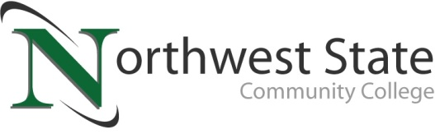

DATE: October 4, 2023
CONTACT: Jim Bellamy 419.267.1267 jbellamy@NorthwestState.edu

NORTHWEST STATE COMMUNITY COLLEGE CENTER FOR LIFELONG LEARNING
TO HOST “SCARY URBAN LEGENDS” PRESENTATION

Archbold, Ohio – The NSCC Center for Lifelong Learning is offering a special presentation on folklore and urban legends, featuring Dr. Allen Berres of Northwest State. The program, titled “Scary Urban Legends,” will be held at Northwest State on Friday, October 20th from 9:00 a.m. to noon in room A202.The cost to attend this event is $16.00.

Come listen to a review of classic scary urban legends and a discussion of why these legends and their descendants continue to live in our social media accounts and imaginations. Dr. Allen Berres studied folklore and urban legends at Ohio State University. He has taught writing and speech courses at Northwest State Community College since 2008.

RESERVE YOUR SPOT TODAY!
Register by Monday, October 16th to reserve your spot. A small continental breakfast begins at 9:00 a.m., and the speaker follows at 9:30 a.m., along with a lunch from noon until 1:00 p.m. To sign up today, call Deb Wikstrom at 419.944.6195, or email lifelong@NorthwestState.edu. For more information on the CFLL, and other upcoming programs, please visit NorthwestState.edu/lifelong-learning.

###

Northwest State Community College is an accredited two-year, state-assisted institution of higher education that has served northwest Ohio since 1969. Northwest State is committed to providing a quality, affordable education with personal attention and small class sizes. The College offers associate degrees with numerous transfer options, short-term certificate programs, and workforce training programs designed to meet the needs of local businesses and industries. For more information, visit NorthwestState.edu or call 419.267.5511.

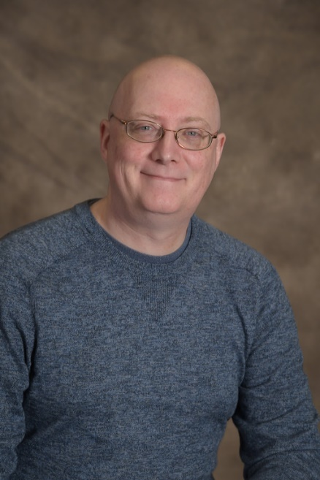
Dr. Allen Berres

