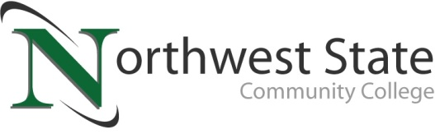

DATE: March 8, 2023
CONTACT: Jim Bellamy 419.267.1267 jbellamy@NorthwestState.edu

NORTHWEST STATE COMMUNITY COLLEGE HOSTS 600+ HIGH SCHOOL STUDENTS
AT OACAC ANNUAL COLLEGE FAIR

Archbold, Ohio – Northwest State Community College hosted the Ohio Association for College Admission Counseling (OACAC) Annual College Fair on Tuesday, March 7th with a tremendous turnout in the Atrium. In total, roughly 55 colleges and universities from a four-state area welcomed over 600 area high school students at the event.
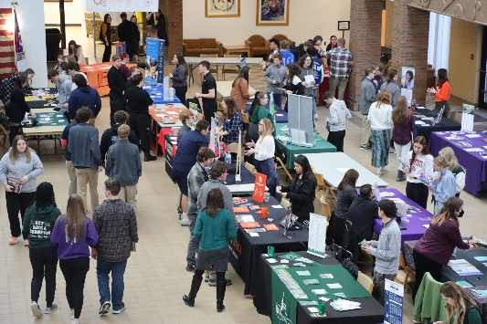
SHOWCASING NSCC AS A COMMUNITY CONVENER
The College Fair allowed Northwest State to serve as a community convener, providing a valuable opportunity for high school students to explore their next steps in their educational journey. Brittany Thompson, NSCC Director of Admissions, noted “It is important for NSCC to host this College Fair, to show area high school students some of the great opportunities that exist after graduation. We appreciate all the colleges and universities for attending. Some students may enter the workforce directly after they graduate, while others may decide to explore higher education. In each case, Northwest State is ready, willing and able to assist learners in achieving their goals.”
Figure 1NSCC hosted the OACAC Annual College Fair on Tuesday, March 7, 2023. In total, over 600 students from area high schools met with roughly 55 colleges and universities from four different states at the event.

OACAC APPROVED COLLEGE FAIRS
From the OACAC website (OACAC.org), OACAC “develops a list of approved college fairs on an annual basis in an effort to encourage and support collaboration between public high schools, private schools and communities. Colleges and universities recognize this as the official list of approved college fairs so they can effectively and efficiently utilize financial and staffing resources to recruit college bound students to their respective universities.”

For more information on Northwest State degree and certificate programs, adult education, workforce development and more, please visit NorthwestState.edu or call NSCC admissions today at 419.267.1320.

###

Northwest State Community College is an accredited two-year, state-assisted institution of higher education that has served northwest Ohio since 1969. Northwest State is committed to providing a quality, affordable education with personal attention and small class sizes. The College offers associate degrees with numerous transfer options, short-term certificate programs, and workforce training programs designed to meet the needs of local businesses and industries. For more information, visit NorthwestState.edu or call 419.267.5511.

