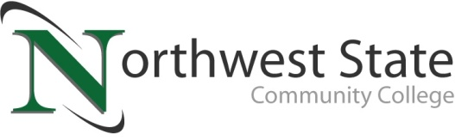

DATE: February 28, 2023
CONTACT: Jim Bellamy 419.267.1267 jbellamy@NorthwestState.edu

NORTHWEST STATE COMMUNITY COLLEGE Excited to ANNOUNCE architectural contract for its van wert campus

VAN WERT, Ohio – Your Van Wert Campus of Northwest State Community College is thrilled to partner with the design firm of Fanning Howey to begin the renovation of its Sycamore Street campus. Fanning Howey is an integrated architecture, interiors and engineering firm specializing in learning environments. Located just 23 miles away from Van Wert in Celina, Ohio, Fanning Howey focuses exclusively on designing learning facilities for the next generation of students. Their team of experts has over 61 years of experience in education design, have worked with 41 colleges and universities on more than 189 projects, and have received more than 180 awards for designs that impact education.

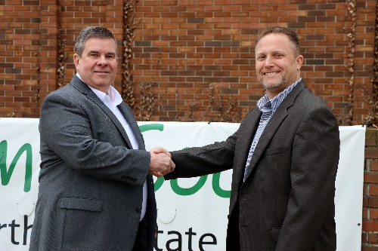
Jon Tomlinson, Dean of the Van Wert Campus, stated “I couldn’t be happier with the selection of Fanning Howey to design Van Wert’s campus. The ideas the team presented to us were spectacular, and will help Northwest State Community College build a first-rate campus for our future students. The Van Wert campus will certainly further our mission of providing access to excellent and affordable education, training, and services that improve the lives of individuals and strengthen the communities in Paulding and Van Wert county.”

“The adaptive reuse of the former office and manufacturing building is an amazing opportunity,” says Tim Lehman, PE, Chief Executive Officer of Fanning Howey. “We look forward to collaborating with Northwest State to reimagine the 20th century facility for use as a 21st century learning environment.”
L to R: Tim Lehman (Fanning Howey) and Dr. Jon Tomlinson (NSCC) at the NSCC Van Wert Campus.

For more information about the Van Wert Campus of Northwest State Community College and to follow the upcoming renovation process, please visit our website at https://northweststate.edu/vanwert. If you would like to learn more about Fanning Howey, you can visit their website at https://fhai.com. You may contact Dr. Tomlinson directly by emailing jtomlinson@northweststate.edu, or visiting our storefront at 122 N. Washington Street.

###

Northwest State Community College is an accredited two-year, state-assisted institution of higher education that has served northwest Ohio since 1969. Northwest State is committed to providing a quality, affordable education with personal attention and small class sizes. The College offers associate degrees with numerous transfer options, short-term certificate programs, and workforce training programs designed to meet the needs of local businesses and industries. For more information, visit NorthwestState.edu or call 419.267.5511.

