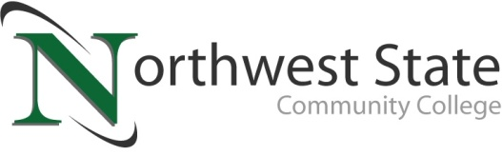

DATE: February 19, 2024
CONTACT: Jim Bellamy 419.267.1267 jbellamy@NorthwestState.edu

NORTHWEST STATE COMMUNITY COLLEGE BOARD OF TRUSTEES
ELECTS NEW OFFICERS

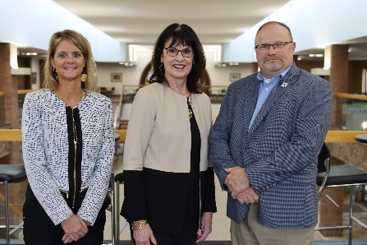
Archbold, Ohio – The Northwest State Community College Board of Trustees met in regular session on Friday, February 16th at the Archbold campus. As part of the meeting’s agenda, the Board elected its new Chair, Vice Chair and Second Vice Chair for the period of February 2024 to February 2025. Sandra Barber (Fulton County) was elected Chair, Katrina DeGroff (Fulton County) was elected Vice Chair, and Mickey Schwarzbek (Defiance County) was elected as Second Vice Chair by the Board. [Photo L to R: DeGroff, Barber, Schwarzbek]

Barber’s current term on the Board expires June 2029, while DeGroff and Schwarzbek have terms expiring June of 2027. Following the nominations, NSCC President Dr. Todd Hernandez presented Scott Mull and Lisa McClure with plaques marking their respective terms as Chair, and offered them each words of gratitude for their dedicated service.

ADDITIONAL HIGHLIGHTS
Prior to electing its new officers for 2024-2025, the Board reviewed and approved the 2023-2024 revised budget. The revised budget is $35,898,289, which is a net adjustment of roughly ($1.8 million). Sandra Barber and John Bridenbaugh were appointed as Delegate and Alternate from the Board to serve on the governing board of the Ohio Association of Community Colleges (OACC). Finally, for the period of April 2024 through February, the following Board regular 2024-2025 meeting dates were approved as follows: April 19, June 21, August 23, October 18, December 13, and February 28 (2025 date).

In other Board action:
- Approved the promotion of Marianna Doolittle to Associate Dean-STEM and Industrial Technologies, and Jose Silva to Operations Manager.
- Approved the employment of Connie Nicely (Controller), Emili Clingaman (Administrative Assistant-Admissions), Stephen Wisner (Training Coordinator-Electrical and Automation), Caitlin Roehrig (Administrative Assistant-Advising Center and Learner Services), Karla Ringenberg (Faculty-Nursing), Craig Kuhlman (Faculty-Business Management and Economics), Diae Mizou (Faculty-Mathematics), Greg Smith (Commander-Law Enforcement Academy), Jodi Adams (Custodian-1st Shift), Jon Thomas (Working Supervisor of Facility Maintenance & Custodial / Van Wert Campus), Gina Kasch (Grants Administrator).
- Approved the 2024-2025 student fees.
- Approved updated facility room rental fees (effective 3/1/24).
- Approved a new Persona Non Grata policy.
- Approved amended graduation requirements.
- Approved miscellaneous employment contracts.
- Approved two resignations and two retirements.

###

Northwest State Community College is an accredited two-year, state-assisted institution of higher education that has served northwest Ohio since 1969. Northwest State is committed to providing a quality, affordable education with personal attention and small class sizes. The College offers associate degrees with numerous transfer options, short-term certificate programs, and workforce training programs designed to meet the needs of local businesses and industries. For more information, visit NorthwestState.edu or call 419.267.5511.

