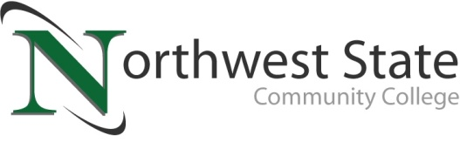

Date: January 10, 2024
Contact: Jim Bellamy, 419.267.1267 jbellamy@NorthwestState.edu

NORTHWEST STATE COMMUNITY COLLEGE FOUNDATION
TO HOST “PURSES FOR A PURPOSE” EVENT

ARCHBOLD, OHIO – The Northwest State Community College Foundation will host a “Purses for a Purpose” purse bingo fundraiser on Friday, February 9th at the Voinovich Auditorium on the Archbold campus. The concept of “Purses for a Purpose” was born from area women wanting to make a difference in their community, and will focus on assisting students who want to attend college by removing financial barriers and making needed scholarship dollars available.

EVENT DETAILS
The event will feature a minimum of 15 bingo games, mystery purse drawings, raffle baskets, heads & tails, and much more. Tickets to the event are $50, and will include heavy hors d’oeuvres and desserts. Event sponsorship opportunities are also available, starting at $100. All proceeds from the event directly fund student scholarships for NSCC students, and make dreams a reality! There is limited seating for the event. Doors open at 4:30 p.m., with bingo beginning at 6:00 p.m. Participants must be 18 years or older to attend.

GET YOUR TICKETS AND SUPPORT STUDENT SCHOLARSHIPS!
Tickets to the “Purses for a Purpose” event at NSCC are now available. For more information, or to purchase tickets, please visit NorthwestState.edu/foundation.

ABOUT THE NSCC FOUNDATION
The NSCC Foundation was established in 1978 to provide support for the students, people and programs of NSCC. For nearly 40 years, the foundation has remained true to its mission to enhance, expand and sustain Northwest State so that NSCC can continue to fulfill its mission of creating opportunities for transformational learning. The NSCC Foundation works diligently to raise much-needed funds for educational opportunities that directly and indirectly impact students.

###

Northwest State Community College is an accredited two-year, state-assisted institution of higher education that has served northwest Ohio since 1969. Northwest State is committed to providing a quality, affordable education with personal attention and small class sizes. The College offers associate degrees with numerous transfer options, short-term certificate programs, and workforce training programs designed to meet the needs of local businesses and industries. For more information, visit NorthwestState.edu or call 419.267.5511.

