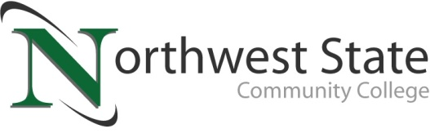

DATE: July 20, 2023
CONTACT: Jim Bellamy | 419.267.1267 | jbellamy@NorthwestState.edu

NSCC PHLEBOTOMY AND MEDICAL ASSISTING
GRADUATES CELEBRATED AT CEREMONY

ARCHBOLD, OHIO –During a special pinning ceremony recently held at Northwest State Community College, seven students from the College’s phlebotomy technician certificate program, and one graduate from the medical assisting degree program were recognized. Both options lead to entry-level positions in the health care field, and students earning the phlebotomy technician certificate may choose to continue their education for an associate degree in medical assisting.

Phlebotomy students recognized:
Fulton County: Rachel Baumgartner (Swanton), Hannah Fritz (Archbold), Karli Luderman (Archbold), Aslinn Meeker (Fayette)
Van Wert County: Lexis McDowell (Convoy)
Williams County: Vanessa Peralez (Bryan), Alethia Stimpfle (Montpelier)

Medical Assisting student recognized:
Williams County: Jillian Spengler (Bryan)

###
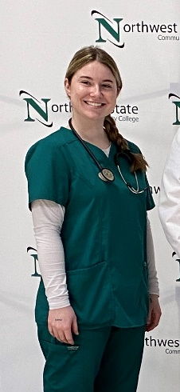

Medical Assisting: Spengler

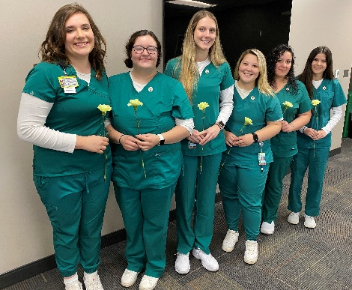
Phlebotomy technicians L to R: Baumgartner, Fritz, Luderman, Peralez, Stimpfle (not pictured: Meeker)

