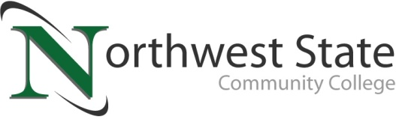

Date: April 15, 2024
Contact: Jim Bellamy | 419.267.1267 | jbellamy@northweststate.edu

NORTHWEST STATE TO HOST SUMMER CAMPS FOR STUDENTS OF ALL AGES!

Archbold, Ohio – Northwest State Community College will host a series of hands-on summer STEM camps for learners of all ages, beginning on June 10 with Music Creation & Performance. The camp season will wrap up on July 11. This year’s summer camp subjects include many of Northwest State’s academic divisions, including Custom Training Solutions (CTS), Arts & Sciences and Nursing & Allied Health, and Business & Public Service. All camps will be hosted at the Archbold campus, and campers can expect fun, hands-on learning activities as part of their action-packed camps.

For all grade ranges listed below, it is the last grade students finished unless the camp specifies otherwise.
JUNE CAMPS
Music Creation & Performance (Grades 6-12) – RoboMania: Where fun meets Future Tech (Grades 3-4) – LEGO Brick Builders (Grades 3-4), Babysitting Basics (Ages 12 & older) – First Aid Camp (Grades 5-12) – Her Royal Scientist Camp (Grades 1-2) – Jr. Brick Builders (Grades 1-2) – Entrepreneurial Adventure (Grades 5-8 and Grades 9-12) – Engineering Innovators (Grades 5-8) – Masters of the LEGO Brick (Grades 5-8) – Wild About Animal Art (Grades 4-8)
JULY CAMPS
Manufacturing Marvels: Exploring Industry Wonders with Spangler Candy and Beyond (Grades 5-8) – Beginning Robotics (Grades 5-7) .

Dr. Todd Hernandez, President at Northwest State, noted “The NSCC summer camps mainly focused on STEM and advanced manufacturing in recent years, but our faculty across campus have really brought some innovative camp ideas to fruition this summer, and we’re excited to see campers of all ages at the College.”

For a complete listing of the Northwest State summer camps, including dates, ages, fees and registration information, please visit NorthwestState.edu/Camps, or contact Jani Tisovic at the College by phone at 419.267.1381 or by email SummerCamps@NorthwestState.edu.

###
Northwest State Community College is an accredited two-year, state-assisted institution of higher education that has served northwest Ohio since 1969. Northwest State is committed to providing a quality, affordable education with personal attention and small class sizes. The College offers associate degrees with numerous transfer options, short-term certificate programs, and workforce training programs designed to meet the needs of local businesses and industries. For more information, visit NorthwestState.edu or call 419.267.5511.

